 26/01/2023
SEAA4113-04
CPM Homework (10%)
By:
Imran Shahriar
Section 04
Faculty of Civil Engineering
Universiti Teknologi Malaysia
To:
Ts. Dr. Suzila Binti Mohd
Universiti Teknologi Malaysia



FACULTY OF CIVIL ENGINEERING HOMEWORK (10%)
COURSE
:
CONSTRUCTION & PROJECT MANAGEMENT
COURSE CODE
:
SKAB/SEAA 4113
LECTURER
:
TS. DR. SUZILA BINTI MOHD
SEMESTER
:
SESSIONS 2022/2023 SEM 1

INTRODUCTION

This course aims to develop understanding on the importance of construction management principles and its related tools. The course starts with understanding the general perspective of management issues and processes and their relationship to construction. The construction project life cycle together with the roles and responsibilities of professionals involved at each stage will be discussed. The Knowledge, Skills, Roles and Ethical responsibilities of a project manager will be explained. The second part of the course will include the usage of tools available in construction management particularly in the application of planning and scheduling technique using Gantt Chart and networking technique. The course will also expose the students to the application of popular scheduling software. The third part of the course is dedicated to the application of scheduling technique related to resource management, resource allocation and project time cost trade-off. The last important topic involves analyzing the project cash flow requirements, project monitoring and control.

LEARNING OUTCOMES

Upon successful completion of the assignment, you will be able to:

- Analyze resources requirement for manpower, machinery, material, and money in construction project.

TASK:

- Homework (10%)
- Answer all questions (Q1 – 23)
- The overall solutions should be prepared in MS Word (indicate or label the answer clearly). Your answer should be supported by reasoning/justification (not just simply answer A, B, C or D).
- A good answer for scheduling questions shall be supported by full solutions (copy and paste from Microsoft Project Software solutions or manual/computer sketches).
- Solution/answer to selected resource management questions. A good answer shall be supported by reasoning (not just simply answer A, B, C or D). LABEL OR SHOW CLEARLY YOUR ANSWER FROM THE CALCULATION TABLE.

SUBMISSION REQUIREMENTS:

- Submit the softcopy report in PDF format (Upload via the official platform) with the file name: SKAB/SEAA 4113_Full Student Name_Matric Number.
- Front cover must include university logo, name of faculty, name of course & subject, the title of assignment (Homework) name of a student, student’s matric number, and name of lecturer.
- Page number must include at bottom of the page

SUBMISSION DATE & TIME:

- Date: 26/01/2023 (Week 15)
- Time: Before 05.00 pm

QUESTION:

Q1. Which of the following aspect are considered as economy aspect affecting value of a machine?
  - Capacity
  - Capital Cost
  - Custom duty
  - Maintenance Cost

- I and II
- I, II and III
- I, II and IV
- All of the above

Q2. Damage caused to a machine naturally as a result of ageing is known as ………?

- Wear and tear.
- Economic obsolescence.
- Functional obsolescence.
- Operating obsolescence.

Q3. Which of the following are considered equipment and machineries?

- Temporary water tank in construction site
- Site Office
- Motorised Cutter and Concrete Compactor
- Generator set and Excavator

- I, II and III
- I, II and IV
- I, III and IV
- All of the above

Q4. Table Q4 and Q7 are data for a small project.

Table Q4
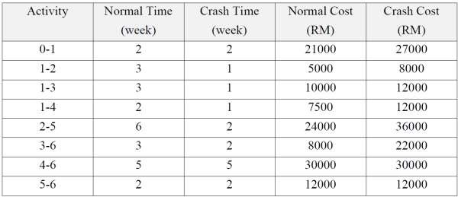
Q4. Given indirect cost per day is RM300.00, Calculate Total Cost of this project: A. RM 3,900
B. RM 144,800
C. RM 11,750
D. RM 27,300

Q5 Which activity indicates the highest increment if time compression needs to be done?

- Activity 1-3
- Activity 1-4
- Activity 2-5
- Activity 3-6

Q6 A decision has been made which activities 1-3 and 2-5 needed to be crashed 2 weeks each due to financial reason. Calculate the new Total Cost of this project?

A. RM 23,100
B. RM 117,500
C. RM 145,300
D. RM 148,600

Q7 Based on the new time of project compression, a labour resource aggregation chart has to be developed using followings number of labours in Table Q7. Calculate the maximum Labour using Total Float- Earliest Start for this project?

Table 7
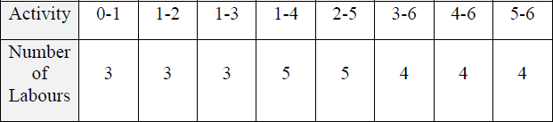

- 12
- 11
- 8
- 15

Q8 Which of the following activities that may contribute to negative cash flow of a contractor?

- Retention money imposed by the client
- Advance payment by the client
- Delay payment to sub-contractor
- Cash payment to supplier

- I and IV
- II and IV
- III and IV
- All of the above

Question Q9 – Q12 are referring to the Table Q9.

Table Q9 shows the cost of works and the program for the construction of a building. The information’s of the project are as the followings:

- The gross profit margin is 15 % of the cost.
- Retention money is 5 %.
- Progress payment is on monthly basis and measurement will be made at the end of each month and the contractor receives the payment one (1) month later.
- The retention money is repaid 3 (three) months after the practical completion.
- The project starts 1 November 2018.

To simplify the calculation, you may assume that all costs must be met at the instant they are incurred. You may also assume that the monthly value and cost for each activity are equally distributed.

Table Q9
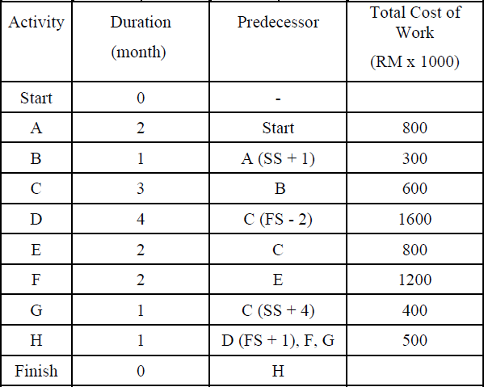

Based on the above information’s, answer the following questions. Q9. What is the contract value of the project?
A. RM 7,130,000
B. RM 6,200,000
C. RM 6,773,500
D. RM 6,227,250

Q10. Calculate the maximum cash required for this project.

A. RM 1,768,750
B. RM 1,224,250
C. RM 1,768,000
D. RM 1,760,000

Q11. At the end of which month, the maximum cash is required?

  - End of March 2019
  - End of April 2019
  - End of May 2019
  - End of June 2019

Q12. What is the expected monthly payment received of all works that are scheduled to be completed in May 2019?

A. RM 655,500
B. RM 874,000
C. RM 1,311,000
D. RM 1,300,000

Q13. A project schedule should reflect the whole scope of work of the project. The whole scope planning process in most proper sequence would be:

- Identify goals => Determine requirements => Define scope => Define work breakdown structure.
- Identify goals => Define work breakdown structure => Define scope => Determine requirements.
- Define work breakdown structure => Determine requirements => Identify goals => Define scope.
- Define scope => Define breakdown structure => Identify goals => Determine requirements.

Q14. These are project-based organisations except:

- Consultants.
- Software Developers.
- Manufacturers.
- Advertising Agencies.

Q15. Which of the following CPM relationships is the least useful in scheduling a project?

- Start-to-Start with or without lags.
- Start-to-Finish with or without lags.
- Finish-to-Finish with or without lags.
- All relationships other than Finish-to-Start with or without lags.

Q16 – Q19 refer to the following diagram:
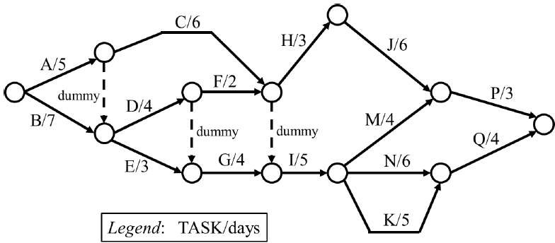

Q16. The earliest time the schedule can be completed is in:

- 26 days
- 27 days
- 30 days
- none of the above

Q17. The task with largest total float is:

- Task H
- Task J
- Task M
- none of the above

Q18. Number of near-critical task (with less than 2 days of total-float):

- 1 task
- 2 tasks
- 3 tasks
- 4 tasks

Q19. How many days further will the total project be extended if Task F takes 5 days to complete instead?

- 0 day
- 1 day
- 3 days
- 5 days

Q20 – Q23 refer to the following table:
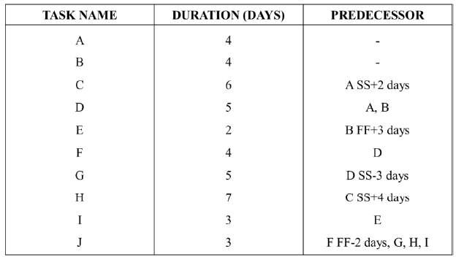

Q20. The schedule early finish is at the end of day:

- 15th
- 16th
- 19th
- other than the above Q21. The total-float for Task G is:
- 3 days
- 4 days
- 5 days
- other than the above

Q22. A correction was made so that Task D actually takes 8 days to complete. What are the effect of that change to the schedule?

- There are now 4 critical activities all together.
- There are now 5 critical activities all together.
- There are now 6 critical activities all together.
- There are now 7 critical activities all together.

Q23. Consider all tasks are back with their original duration again as given in the table. If Task E takes 6 days instead of 2 days to complete, will the schedule completion time be extended too?

- Yes, extended by 1 day.
- No, but Task E becomes critical.
- Yes, extended by more than 1 day.
- No, everything else remain the same.

